FOR IMMEDIATE RELEASE CONTACT:
Lernard Freeman
Weichert Real Estate Affiliates, Inc.
973-401-5578
lfreeman@weichertrealtors.net

Weichert, Realtors® - Centennial Announces 2017 Office Award Winners
REALTOR® Tracey Veal Named Top Agent
NORMAN, Okla. / April 23, 2018 – Weichert, Realtors® - Centennial, located in Norman, is proud to announce their 2017 Office Award winners. REALTOR Tracey Veal was named the top producing agent at the Weichert® affiliate last year, earning the prestigious President’s Club Award from Weichert Real Estate Affiliates, Inc. for her 2017 sales production.

In addition, three other agents at Weichert, Realtors® - Centennial were honored by the national franchise organization for their 2017 sales production. REALTORS Mitch Biesemeyer and Angela Richards each received the Executive Club Award, while Wendy Williams was named a Sales Achievement Award winner.
Tracey Veal
All awards are based on achieving specified production requirements in gross commission income or units earned
in 2017.
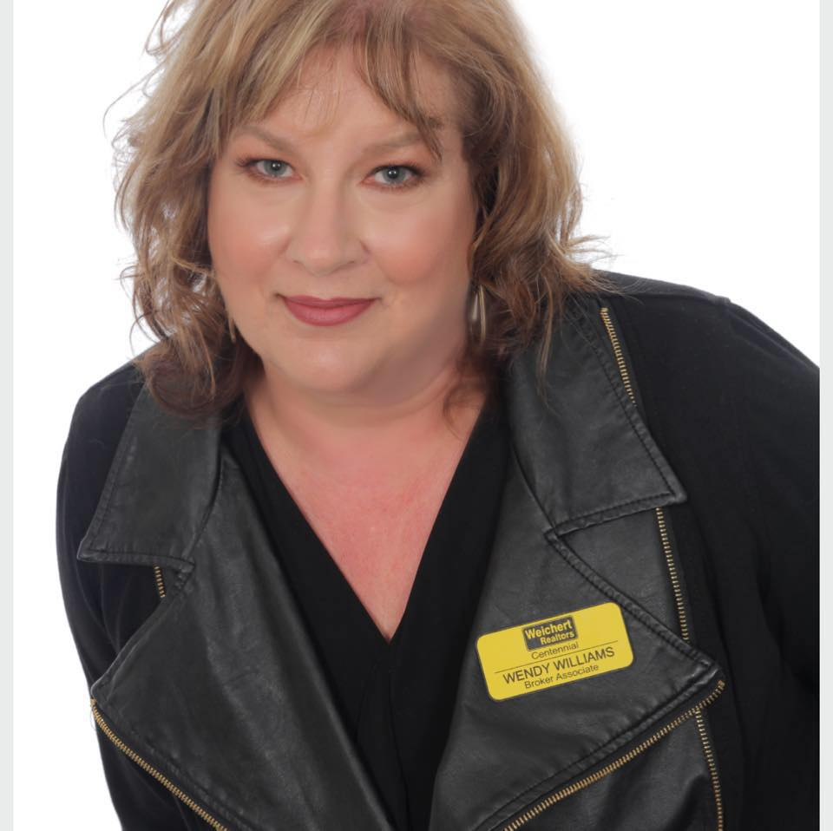
“Tracey, Mitch, Angela and Wendy are each shining examples of how dedication and drive can lead to tremendous success in real estate,” said Tony Graham, the broker/owner of Weichert, Realtors® - Centennial. “Each of them went above and beyond last year to provide their clients the best real estate service in the industry. We’re proud to have them on our team and honor their achievements.”
Wendy Williams
Angela Richards
Mitch Biesemeyer

Weichert, Realtors® - Centennial is an independently owned and operated Weichert affiliate. The office serves the
Oklahoma City metro area.

For more information about Weichert, Realtors® - Centennial, located at 360 24th Avenue, NW, Suite 126, in Norman, contact Tony Graham at 405-360-0303 or visit www.wrcok.com/Home.

# # #

About Weichert Real Estate Affiliates, Inc.: Weichert Real Estate Affiliates, Inc. has grown steadily since Jim Weichert, president, chairman and CEO of Weichert Companies, launched the company’s franchise division in 2001. The affiliate division was created to offer a business model for franchisee ownership candidates described as “a clearly defined operating system for marketing and managing a real estate business.” Weichert Real Estate Affiliates, Inc. announced its first affiliate in 2002, was ranked as one of the top traditional residential real estate franchises in Entrepreneur’s 2018 Franchise 500 and was identified in 2018 by Franchise Business Review as one of the top U.S. franchises for owner satisfaction. Weichert Real Estate Affiliates, Inc. has offices serving over 300 markets in 37 states. For more information about Weichert, visit Weichert.com or for information on franchise opportunities visit WeichertFranchise.com.

Each Weichert® franchised office is independently owned and operated.

